

DEPARTMENT OF FORENSIC SCIENCE

CYBER RANGE

ACTIVITY - 2
“Incident Response Automation Cyber Range”

Submitted By,
Name: Akanksha K J
USN no: 24MSRDF039
Class: 4th semester MSc DFIS

Submitted To,
Mr. Vishnu Venkatesh,
Assistant Professor, Department of Forensic Science,
School of Sciences,
Jain (deemed-to-be) University, JC road
ABSTRACT
In the modern digital era, cyber threats have evolved significantly in complexity, scale, and frequency. Organizations are increasingly exposed to various forms of cyber-attacks such as brute force attacks, malware infections, and data exfiltration. To effectively understand and mitigate such threats, cybersecurity professionals rely on simulated environments known as cyber ranges.
This project presents the design and implementation of an Incident Response Automation Cyber Range, which follows the concept of Cyber Range as a Service (CRaaS). The system provides an interactive graphical interface that allows users to simulate cyber-attacks and observe real-time detection and automated responses.
The system supports three major attack scenarios: brute force attacks, malware execution, and data exfiltration. Each attack is triggered through user interaction, making the simulation more realistic and engaging. The system logs all activities, analyzes them using a detection engine, and triggers appropriate responses automatically.
This project demonstrates the integration of attack simulation, detection mechanisms, response automation, and forensic logging into a unified system. It serves as an effective educational tool for understanding cybersecurity operations and incident response workflows.

TABLE OF CONTENTS
- Introduction
- Objectives
- Literature Review
- System Architecture
- Methodology
- Implementation Details
- Results
- Discussion
- Applications
- Scope and Future Work
- Conclusion
- References

1. INTRODUCTION
Cybersecurity has become a critical domain due to the increasing reliance on digital systems and networks. With the rapid growth of internet-based services, organizations face a wide range of threats, including unauthorized access, malicious software, and data breaches.
A cyber range is a controlled environment designed to simulate real-world cyber-attack scenarios. It enables cybersecurity professionals and students to practice detection, response, and mitigation techniques without affecting real systems.
This project implements a Cyber Range as a Service (CRaaS) model, which allows users to interact with simulated attack scenarios through a graphical interface. Unlike traditional systems where attacks are pre-programmed, this project emphasizes interactive simulation, where user actions directly influence system behaviour.
The system integrates multiple modules such as attack simulation, detection engine, response engine, forensic logging, and report generation. These components work together to simulate a complete incident response lifecycle.
The primary goal of this project is to provide a practical understanding of how cybersecurity systems detect and respond to threats in real-time.

2. OBJECTIVES
The objectives of this project are:
- To design and implement a GUI-based cyber range simulation system
- To simulate different types of cyber-attacks in an interactive manner
- To develop a detection engine based on log analysis
- To implement automated response mechanisms
- To provide real-time visualization of system activities
- To maintain logs for forensic analysis
- To generate structured incident reports
- To enhance understanding of cybersecurity concepts through practical implementation

3. SYSTEM ARCHITECTURE
The system follows a modular architecture consisting of the following components:
- User Interface (GUI)
- Attack Simulation Module
- Logging Mechanism
- Detection Engine
- Response Engine
- Report Generator
Workflow:
User Action → Log Generation → Detection Engine → Response Engine → GUI Output
Each module performs a specific function and communicates with others through structured data.
Insert Screenshot: System Architecture Diagram (optional)
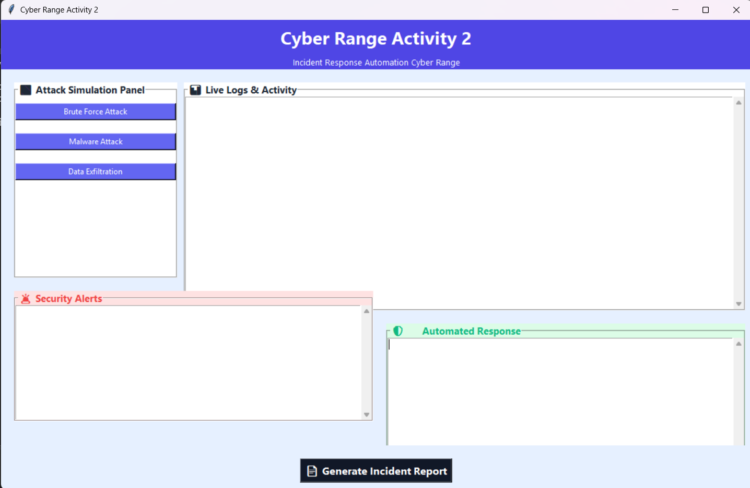

4. METHODOLOGY
4.1 Brute Force Attack Simulation
The brute force simulation replicates repeated login attempts using incorrect credentials.
Steps:
- User clicks on “Brute Force Attack”
- Login window appears
- User enters incorrect passwords
- System logs each attempt
- Detection engine counts failed attempts
- After threshold, attack is detected
- Alert is generated
- Account is locked
Explanation:
This method demonstrates how systems detect repeated unauthorized login attempts. It is based on analysing patterns rather than individual events.
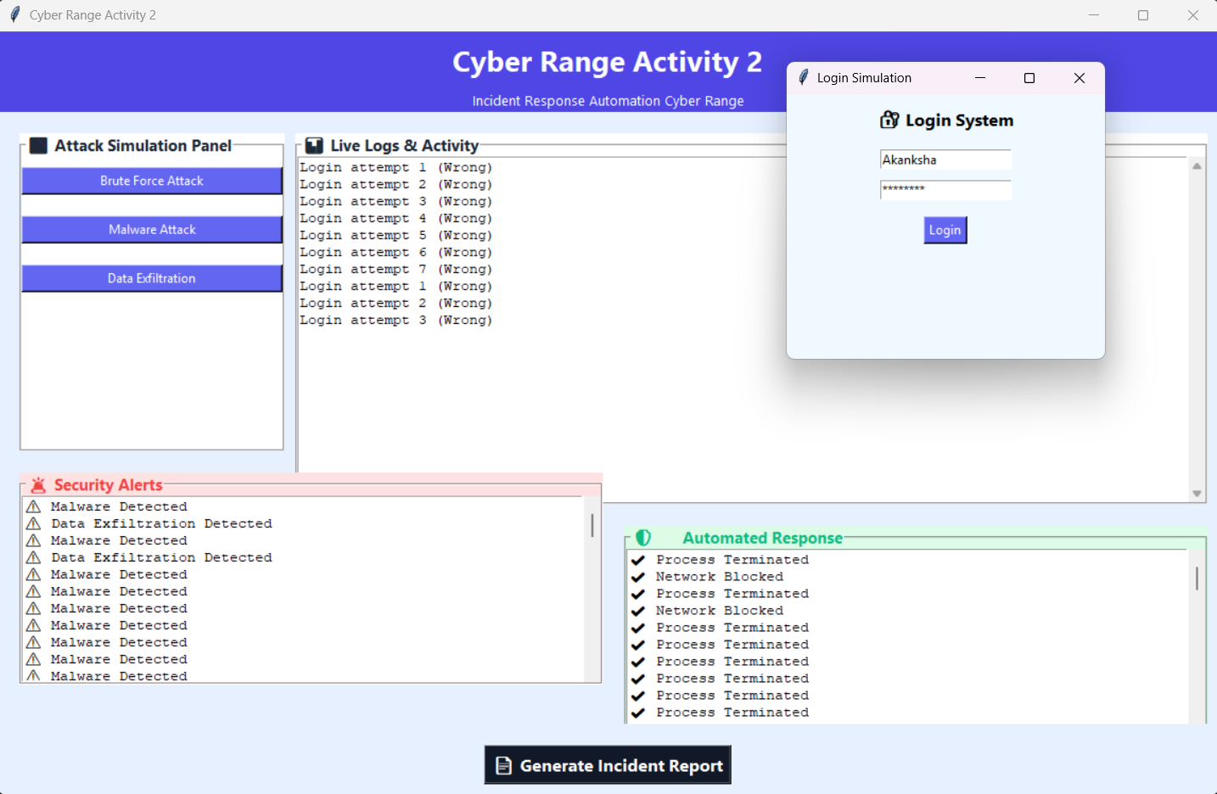
- Login popup
- Failed attempts
- Alert panel

4.2 Malware Simulation
This module simulates execution of malicious software.
Steps:
- User selects malware option
- Popup asks to run file
- User executes file
- Log is generated
- Detection engine identifies threat
- Response engine terminates process
Explanation:
This simulates endpoint security behaviour where suspicious programs are detected and blocked.
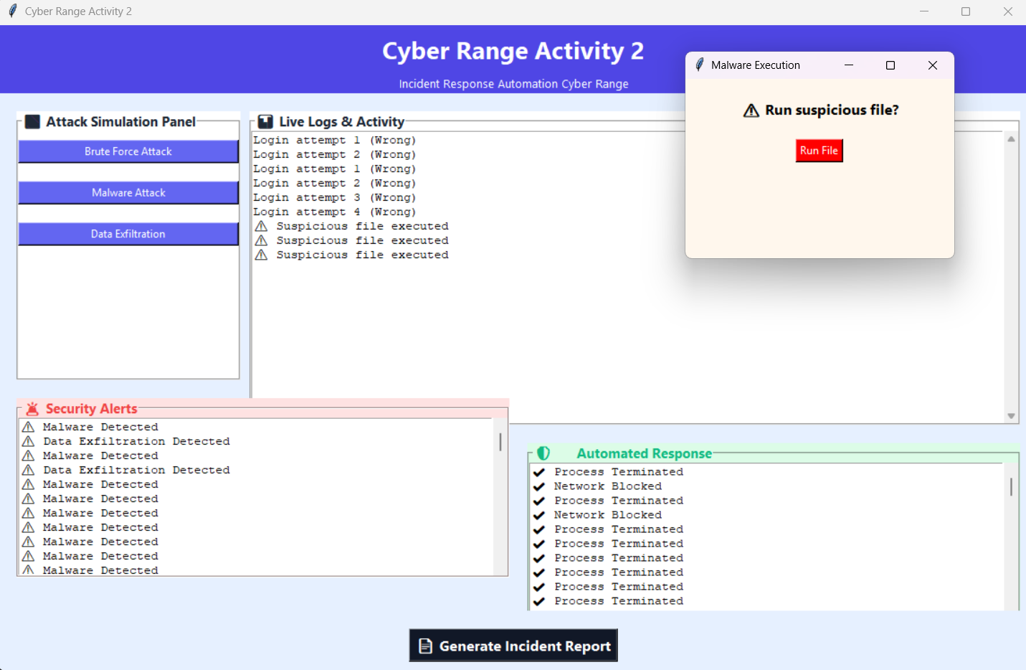
- Malware popup
- Alert

4.3 Data Exfiltration Simulation
This module simulates unauthorized data transfer.
Steps:
- User initiates data transfer
- System logs multiple data chunks
- Detection engine identifies abnormal pattern
- Alert is generated
- Network is blocked
Explanation:
This demonstrates detection of data leakage through unusual activity patterns.
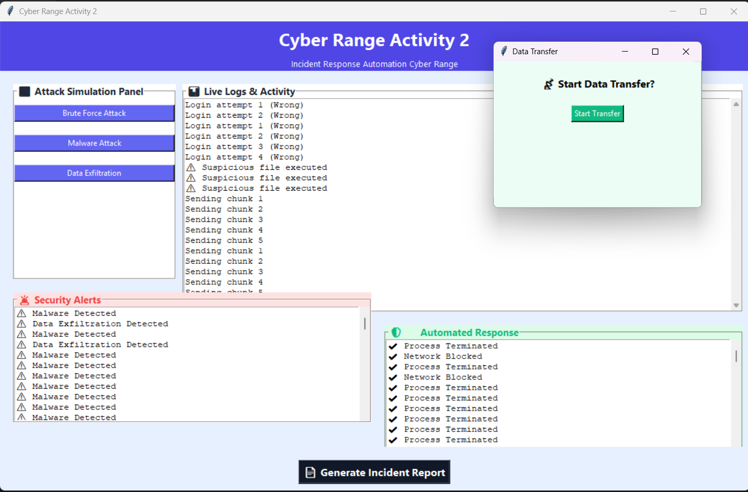
- Data transfer logs
- Alerts
4.4 Logging and Detection
All events are stored in JSON format. The detection engine analyzes logs using rule-based logic such as:
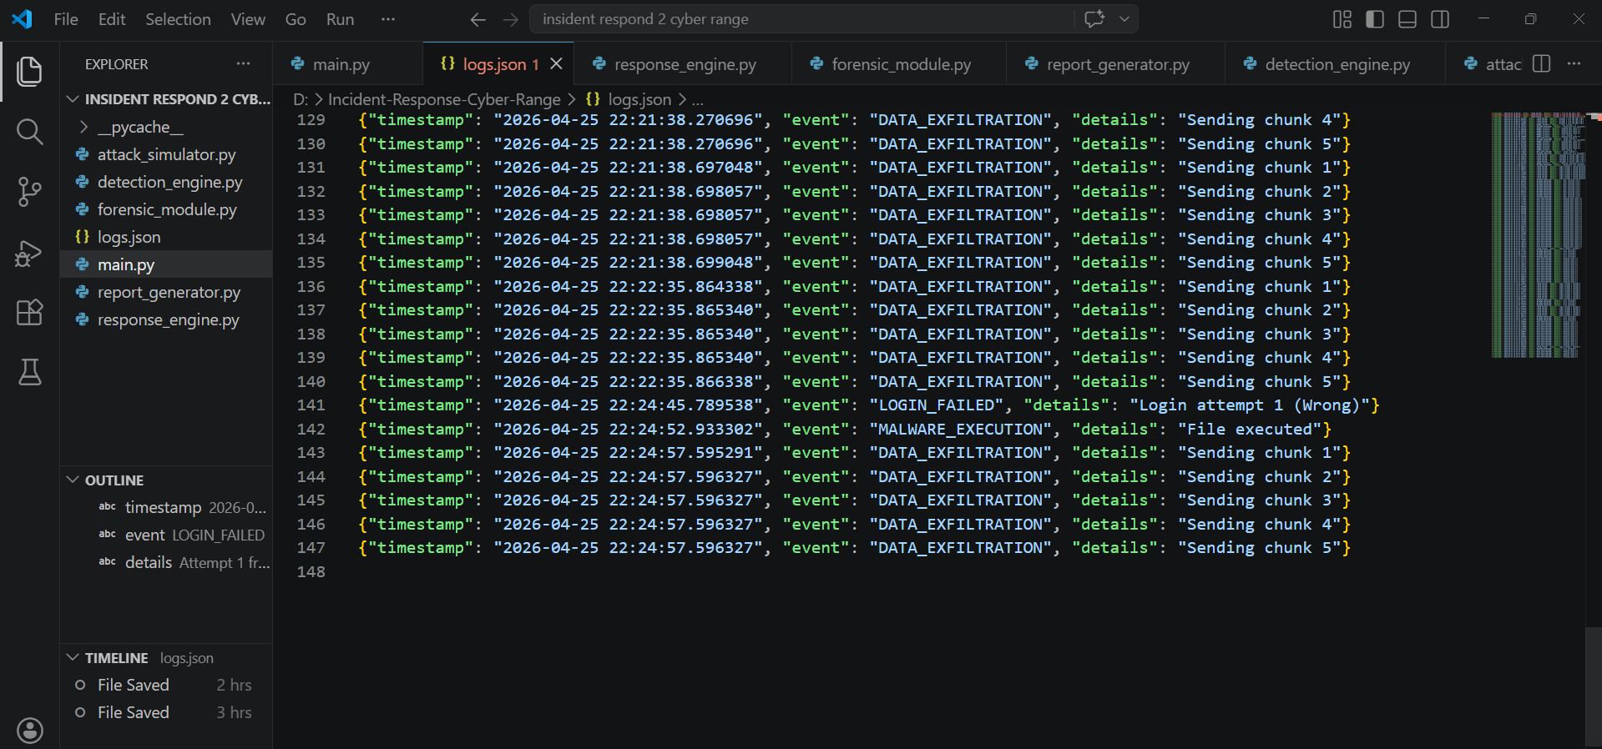
- Counting login failures
- Identifying suspicious execution
- Detecting repeated data transfers
This ensures efficient and real-time detection.
4.5 Response Mechanism
The response engine takes automated actions:
- Account Lock
- Process Termination
- Network Blocking
This demonstrates automated incident response systems used in real-world environments.

5. IMPLEMENTATION DETAILS
The project is implemented using Python programming language. The graphical interface is developed using Tkinter.
Key components include:
- GUI layout using frames and buttons
- Event handling for user actions
- File-based logging using JSON
- Modular code structure
The system is designed to be simple yet effective, allowing easy understanding and modification.

6. RESULTS
The system was tested under different scenarios and produced expected results:
- Brute force attacks were detected after multiple attempts
- Malware execution was identified instantly
- Data exfiltration was detected based on activity patterns
The GUI successfully displayed logs, alerts, and responses in real-time.
Insert Screenshot:
- Full dashboard
GitHub Repository link: https://github.com/AkankshaKJ09/Incident-Response-Cyber-Range

7. DISCUSSION
The project demonstrates the effectiveness of rule-based detection systems. It highlights how user behavior can be analyzed to identify threats.
Advantages:
- Interactive simulation
- Real-time detection
- Clear visualization
Limitations:
- No machine learning
- Limited attack scenarios

8. APPLICATIONS
- Cybersecurity training
- Educational tools
- Security awareness
- Research simulations

9. SCOPE AND FUTURE WORK
- Integration with AI-based detection
- Cloud-based deployment
- Multi-user simulation
- Real-time network data integration

10. CONCLUSION
This project successfully implements a cyber range simulation system that combines attack simulation, detection, response, and logging. It provides a practical platform for understanding cybersecurity concepts and demonstrates the importance of automated incident response.

11. REFERENCES
- Agrawal, A., Nadeem, M., Al Nuaim, A., & Al Nuaim, A. (2026). Artificial intelligence driven multi agent framework for adaptive cyber attack simulation and automated incident response in cyber range environments. Scientific Reports.
- Vyas, S., Mavroudis, V., & Burnap, P. (2025). Towards the deployment of realistic autonomous cyber network defence: A systematic review. ACM Computing Surveys, 58(1), 1-36.
- Kiely, M., Bowman, D., Standen, M., & Moir, C. (2023). On autonomous agents in a cyber defence environment. arXiv preprint arXiv:2309.07388.
- Obuse, E., Etim, E. D., Essien, I. A., Cadet, E., Ajayi, J. O., Erigha, E. D., & Babatunde, L. A. (2023). AI-powered incident response automation in critical infrastructure protection. International Journal of Advanced Multidisciplinary Research Studies, 3(1), 1156-1171.
- Gustafsson, T., & Almroth, J. (2020, November). Cyber range automation overview with a case study of CRATE. In Nordic Conference on Secure IT Systems (pp. 192-209). Cham: Springer International Publishing.

